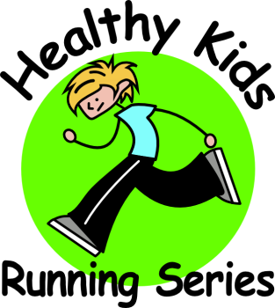
News Release
The Mill, 381 Brinton Lake Road, Thornton, PA 19373
Healthy Kids Running Series
(484) 356-1024
www.HealthyKidsRunningSeries.com

FOR IMMEDIATE RELEASE: May 3, 2013

Healthy Kids Running Series Officially Receives 501(c)(3) Non-Profit Tax Exempt Status

Thornton, Pa – May 3, 2013 – Healthy Kids Running Series (“HKRS”) is proud to announce that they have received 501(c)(3) status of the United States Internal Revenue Code. Registrations and contributions submitted to the Healthy Kids Running Series are now fully tax-deductible dating back to January 17, 2012, when HKRS initially registered as a non-profit corporation with the Commonwealth of Pennsylvania.

“We are very excited to take this next step, obtaining 501(c)(3) status is a milestone that will surely benefit our families, runners, sponsors and ultimately our program” said Scott Ely, Director of Healthy Kids Running Series. “We look forward to continuing to grow this great program in towns across the country.”

Jeff Long, Founder and President of Pattison Sports Group created the Healthy Kids Running Series to provide kids with a positive, educational, and fun experience in the world of running. To combat the increasing rates of child obesity in America, Jeff designed a running program that would motivate kids to be healthy and active and provide a fun environment to improve their self-esteem. Jeff believed the program would encourage kids to adopt a “Get Up and Go” attitude.

The Healthy Kids Running Series is a five-week running program in the spring and fall for kids from Pre-K to 8th grade. Each Race Series takes place once a week and offers age appropriate running events including the 50-yard dash, the 1/4-mile, the 1/2-mile and the one-mile run.

To learn more about the Healthy Kids Running Series, visit www.healthykidsrunningseries.com or call Scott Ely at (484) 356-1024. Be sure to like the ’Healthy Kids Running Series’ page on Facebook and follow @HealthyKidsRS on Twitter to stay up to date with the Healthy Kids Running Series.

###

